**ARYAMAN MISHRA**

**19BCE1027**

**LAB 2 WEB MINING**

Wikipedia link: <https://en.wikipedia.org/wiki/2020_Formula_One_World_Championship>

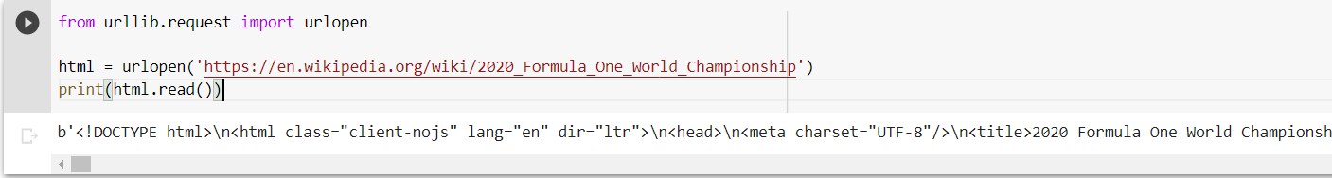

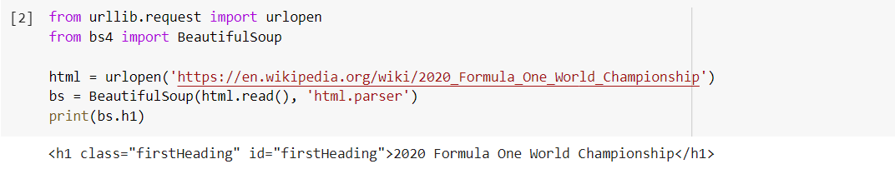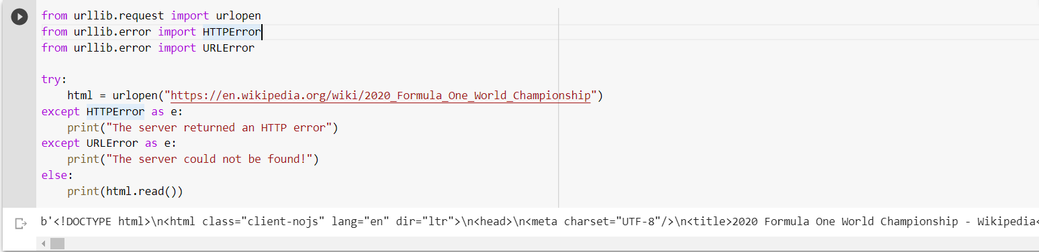

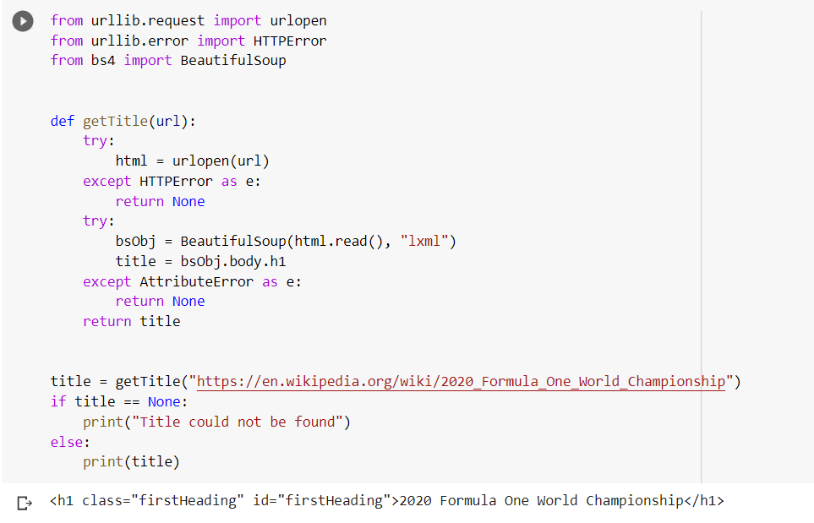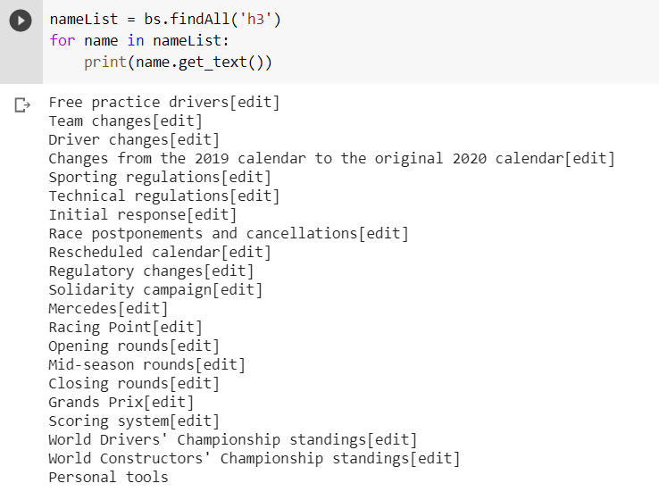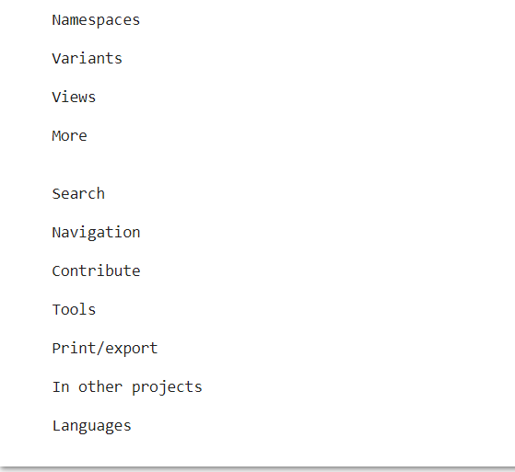

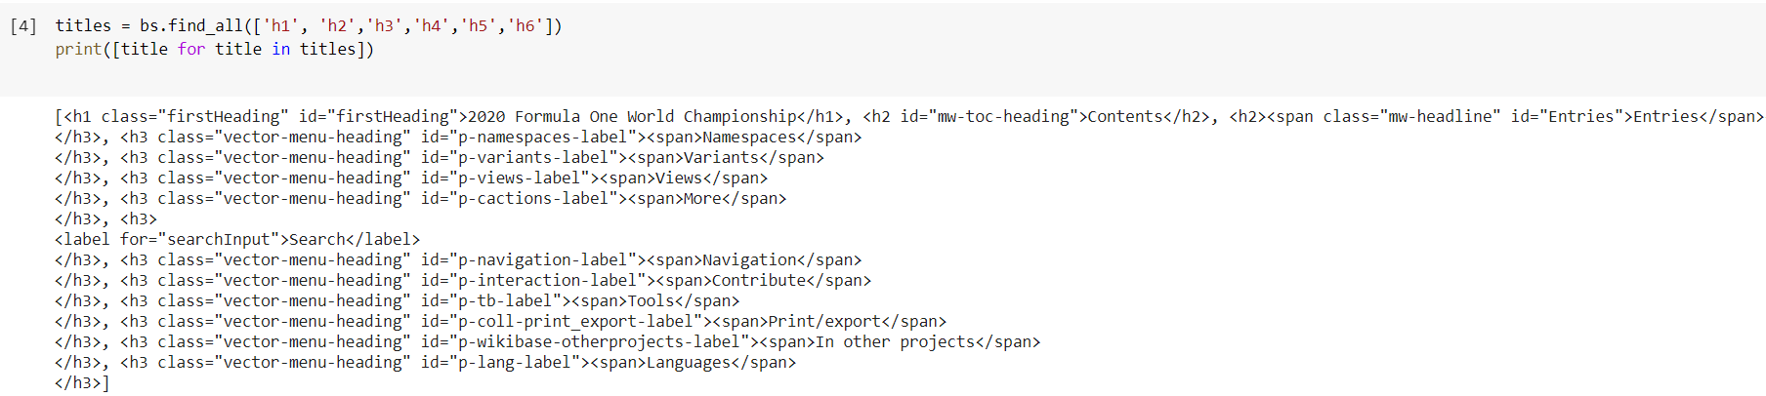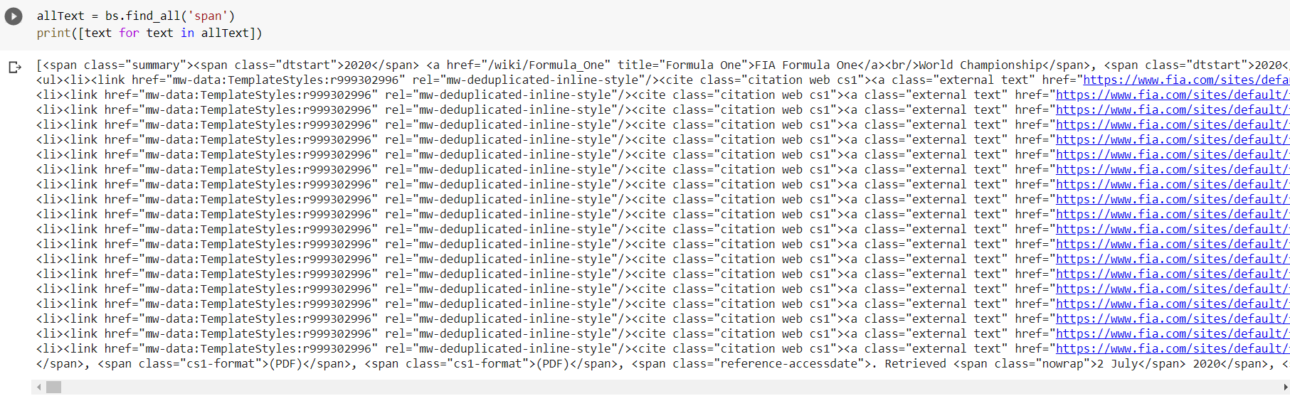

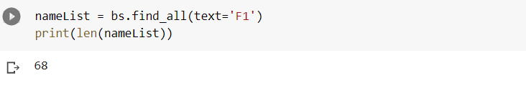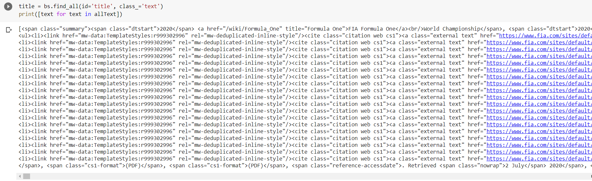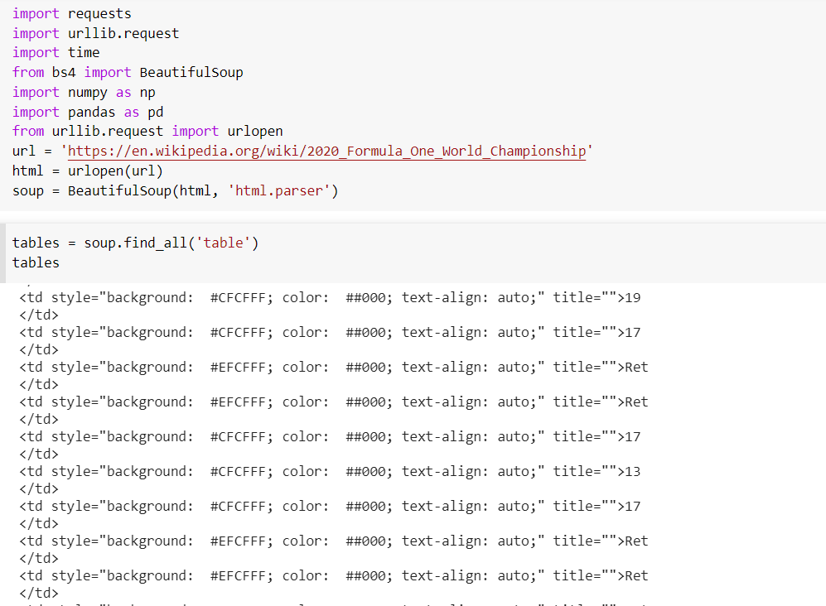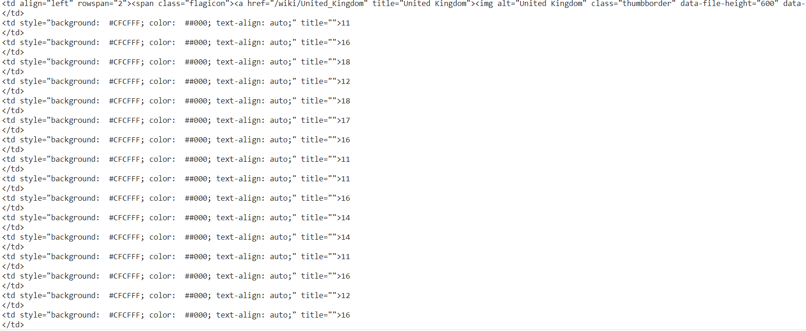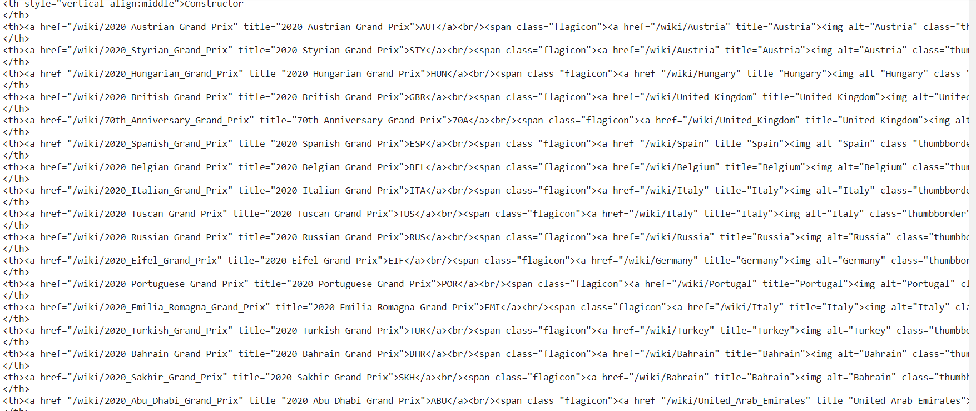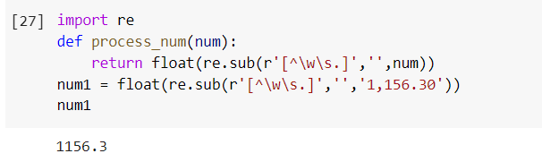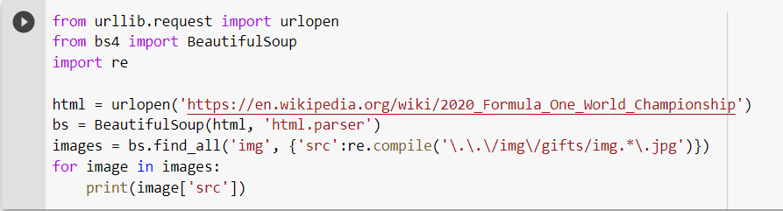

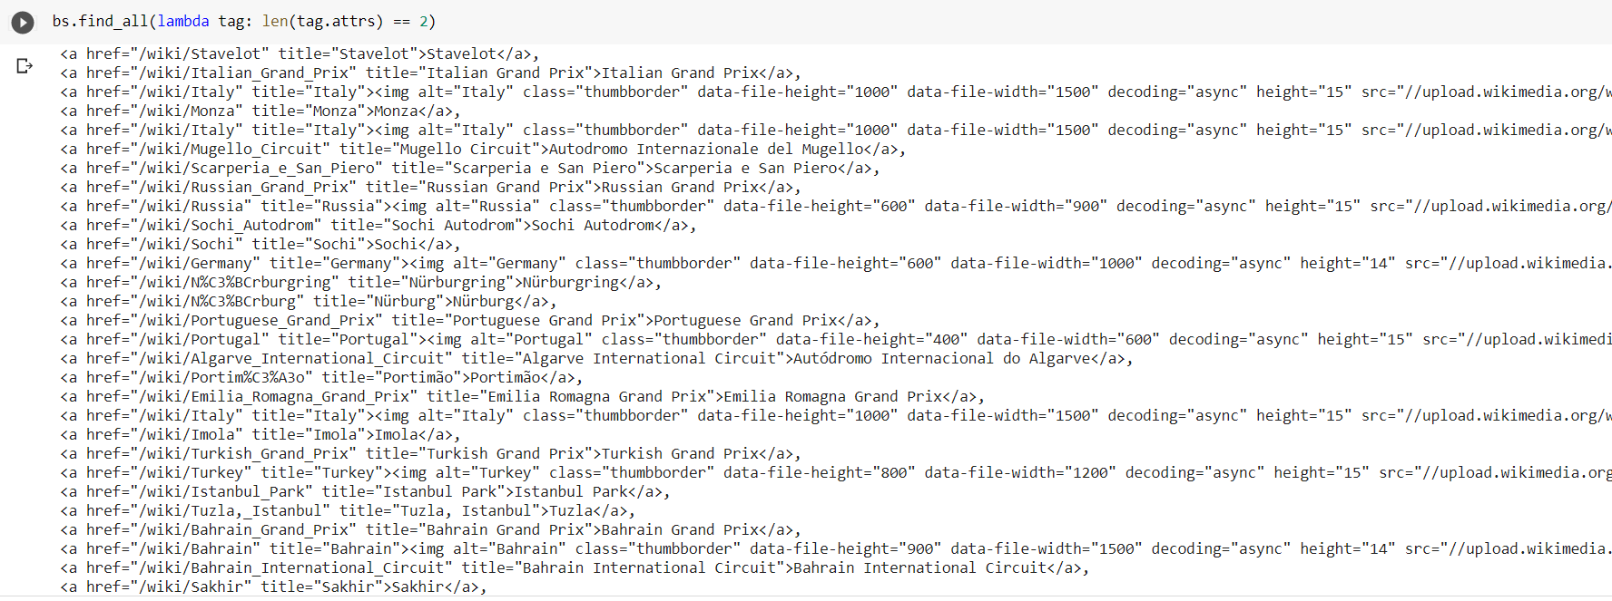

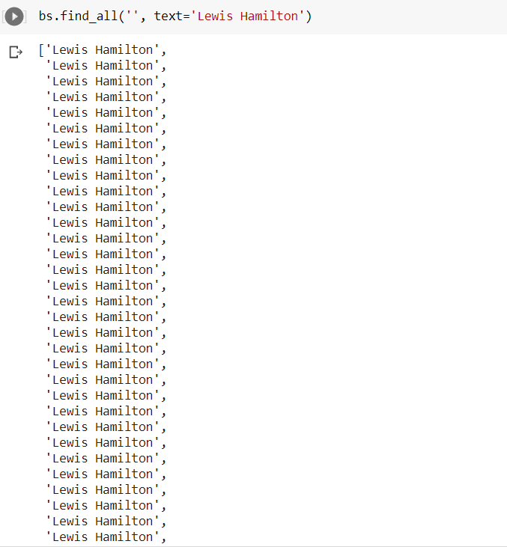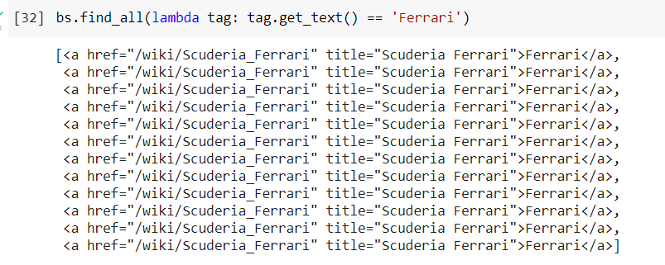

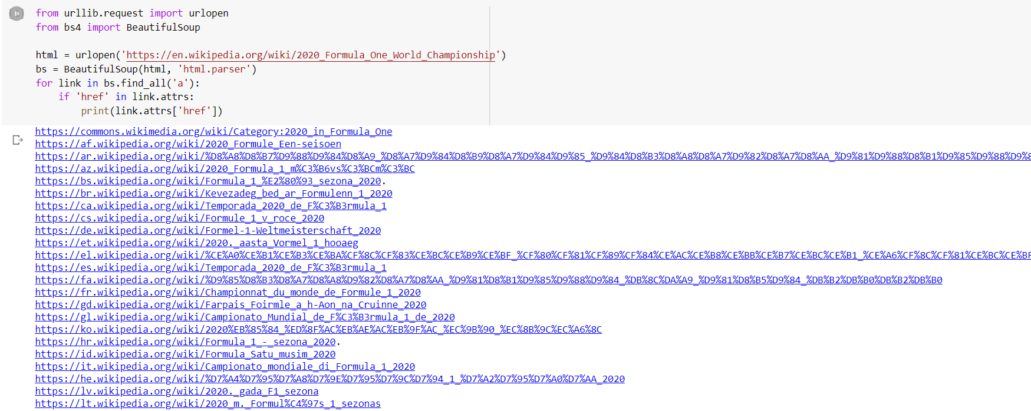

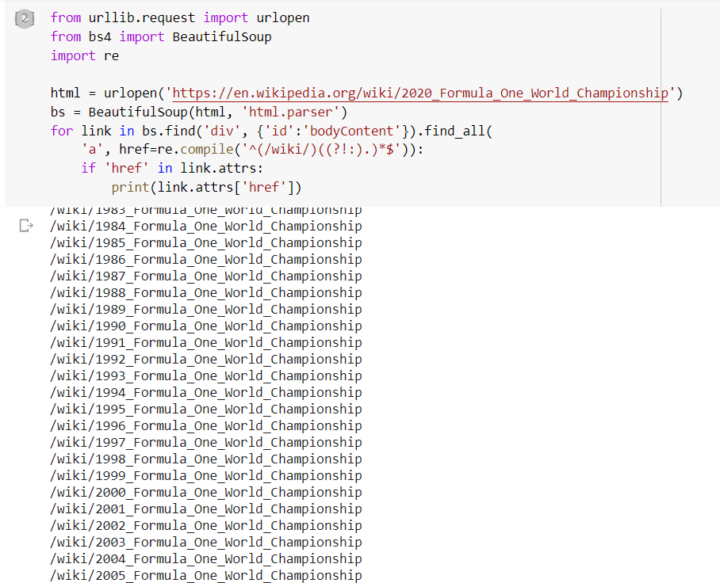

from urllib.request import urlopen  
from urllib.error import HTTPError  
from bs4 import BeautifulSoup  
import sys  
  
  
def getTitle(url):  
 try:  
 html = urlopen(url)  
 except HTTPError as e:  
 print(e)  
 return None  
 try:  
 bsObj = BeautifulSoup(html, "html.parser")  
 title = bsObj.body.h1  
 except AttributeError as e:  
 return None  
 return title  
  
title = getTitle("https://en.wikipedia.org/wiki/2020_Formula_One_World_Championship")  
if title == None:  
 print("Title could not be found")  
else:  
 print(title)

